Lecture 3:
- Function (local, global variable) (scope, life time)
- Recursion
- Single Dimension Array
Lab:
- Car rental service charges a minimum fee of $25.00 to rent a car for 8 hours, and retal after 8 hours. The maximum charge per day is $50 exclusive of service tax. The company charges an additional $0.50 per hour as service tax. Assume that no car is rented for more than 72 hours at a time. If a car is rented for more than 24 hours, then rental is calculated on a daily basis. Write a program that calculates and prints the rental charges for each of three customers who rented cars from this agency yesterday. You should enter the hours for which the car has been rented for each customer. Your program should print the results in a neat tabular format and should calculate and print the total of yesterday’s receipts. The program should use the function calculateCharges to determine the charges for each customer. Your outputs should appear in the following format:
Car Hours Charge
1 12 56.00
2 34 117.00
3 48 124.00
TOTAL 94 297.00
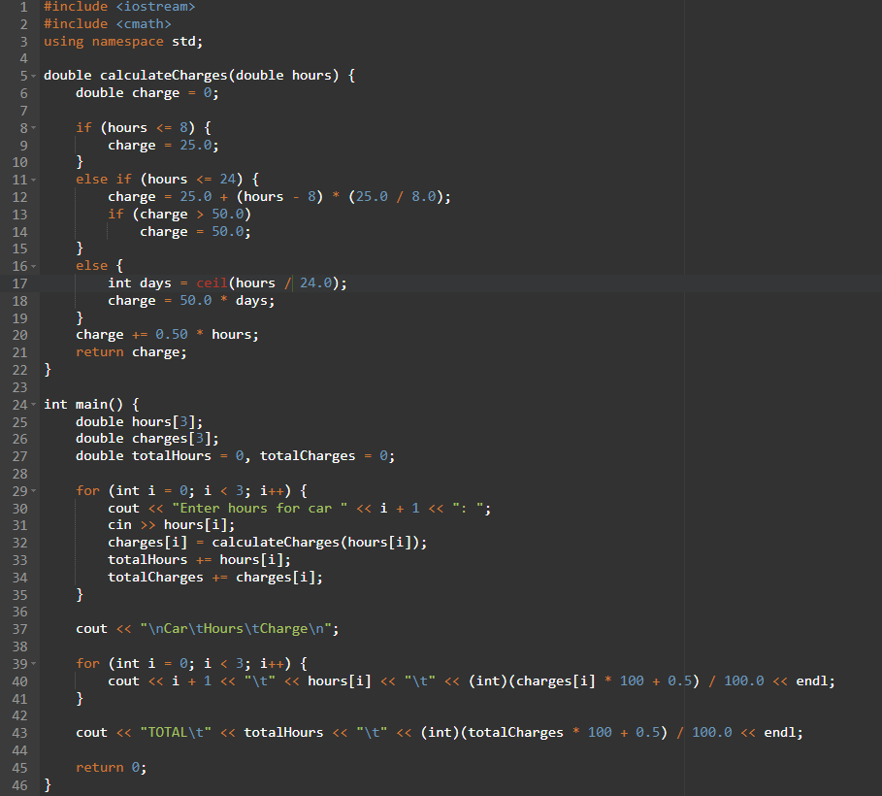

- Define a function called hypotenuse that calculates the length of the hypotenuse of a right triangle when the other two sides are given. The function should take two arguments of type double and return the hypotenuse as a double.
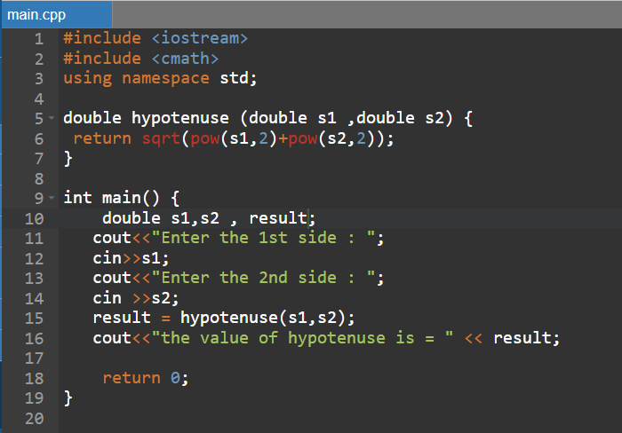
- Write a function that reads three nonzero double values (a, b, c) as the sides of a triangle, and calculates and returns the area of the triangle as a double variable. It should also check whether the numbers represent the sides of a triangle before calculating the area.
$$Area= \sqrt{s\left(s-a\right)\left(s-b\right)\left(s-c\right)}$$
$$s= \frac{a+b+c}{2}$$
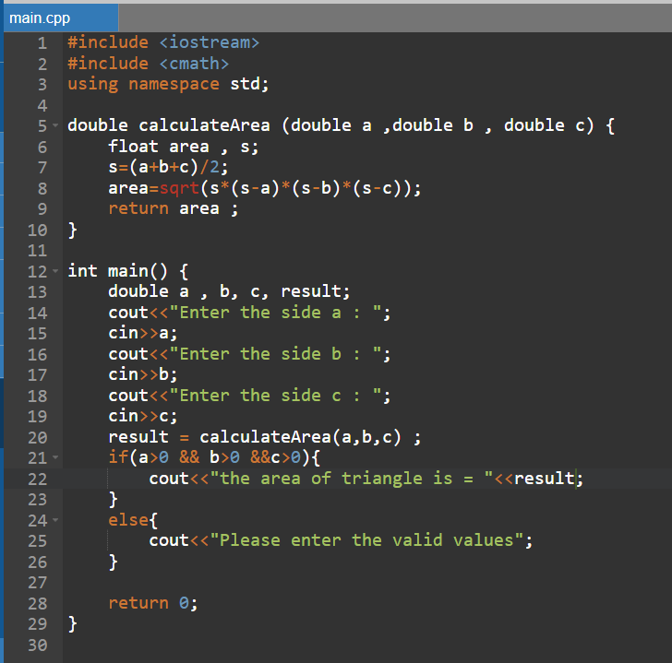

- Write a function that reads three nonzero integers and determines whether they are the sides of a right-angled triangle. The function should take three integer arguments and return 1 (true) if the arguments comprise a right-angled triangle, and 0 (false) otherwise. Use this function in a program that inputs a series of sets of integers.
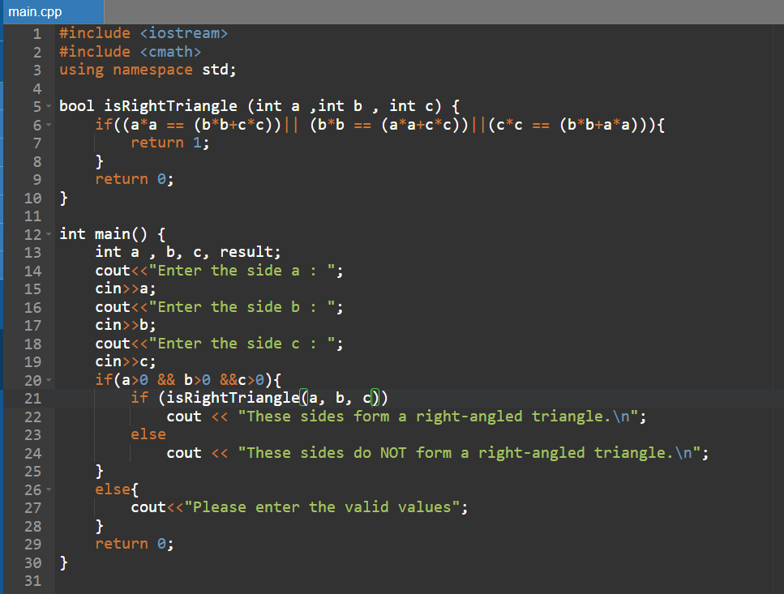

- Implement the following double functions:
a) Function toYen takes an amount in US dollars and returns the Yen equivalent.
b) Function toEuro takes an amount in US dollars and return the Euro equivalent
c) Use these functions to write a program that prints charts showing the Yen and Euro equivalents of a range of dollar amounts. Print the outputs in a neat tabular format. Use an exchange rate of 1 USD = 118.87 Yen and 1 USD = 0.92 Euro.
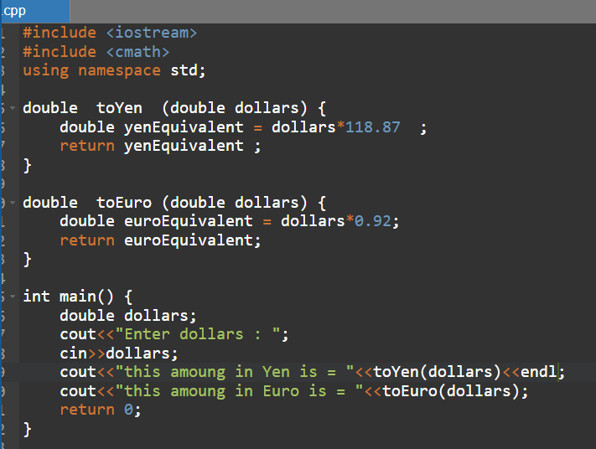
- Write a function that takes an integer and returns the sum of its digits. For example, given the number 7631, the function should return 17.
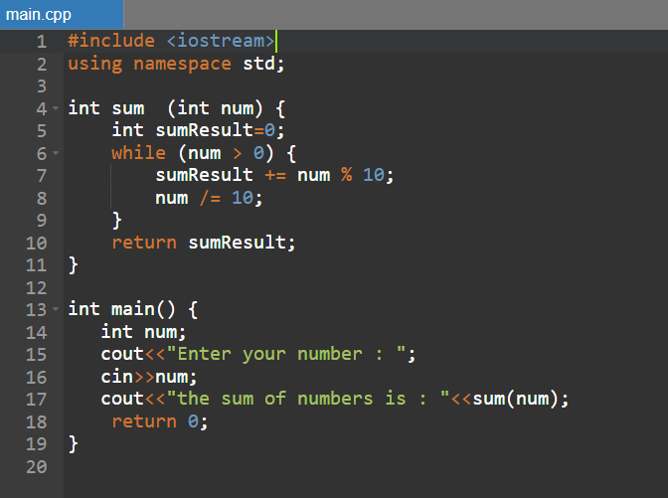

- Write a recursive function power(base, exponent) that when invoked returns base^{exponent} For example, power(3, 4) = 3 * 3 * 3 * 3. Assume that exponent is an integer greater than or equal to 1.
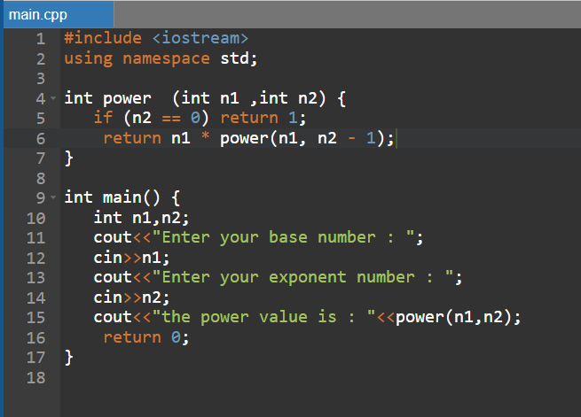

- The Fibonacci series 0, 1, 1, 2, 3, 5, 8, 13, 21, … begins with the terms 0 and 1 and has the property that each succeeding term is the sum of the two preceding terms.
a) Write a non recursive function fibonacci(n) that calculates the n^{th} Fibonacci number. Use unsigned int for the function’s parameter and unsigned long long int for its return type.
b) Determine the largest Fibonacci number that can be printed on your system.
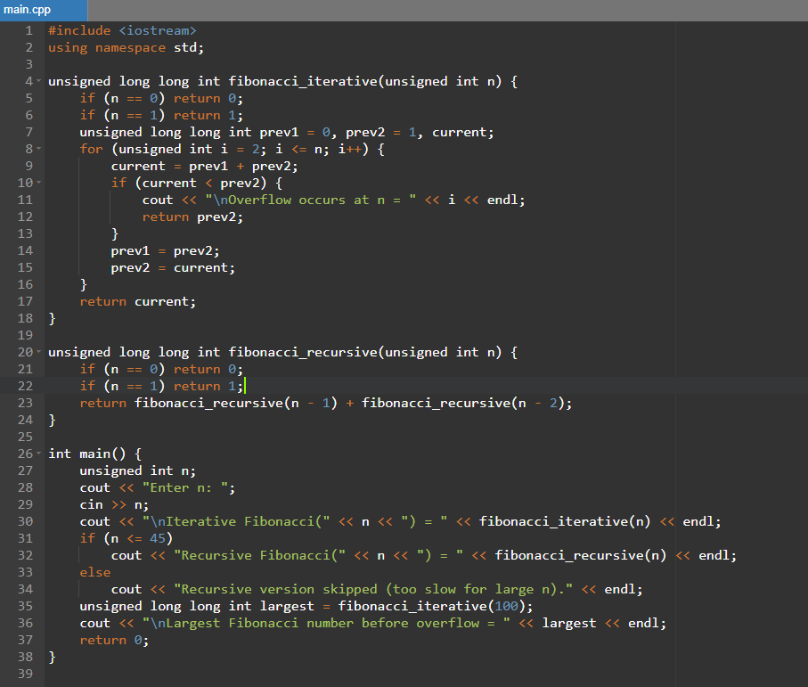
- Use a one-dimensional array to solve the following problem. A company pays its salespeople on a commission basis. The salespeople receive $200 per week plus 9% of their gross sales for that week. For example, a salesperson who grosses $3,000 in sales in a week receives $200 plus 9% of $3,000, or a total of $470. Write a C program (using an array of counters) that determines how many of the salespeople earned salaries in each of the following ranges (assume that each salesperson’s salary is truncated to an integer amount):
a) $200–299
b) $300–399
c) $400–499
d) $500–599
e) $600–699
f) $700–799
g) $800–899
h) $900–999
i) $1000 and over
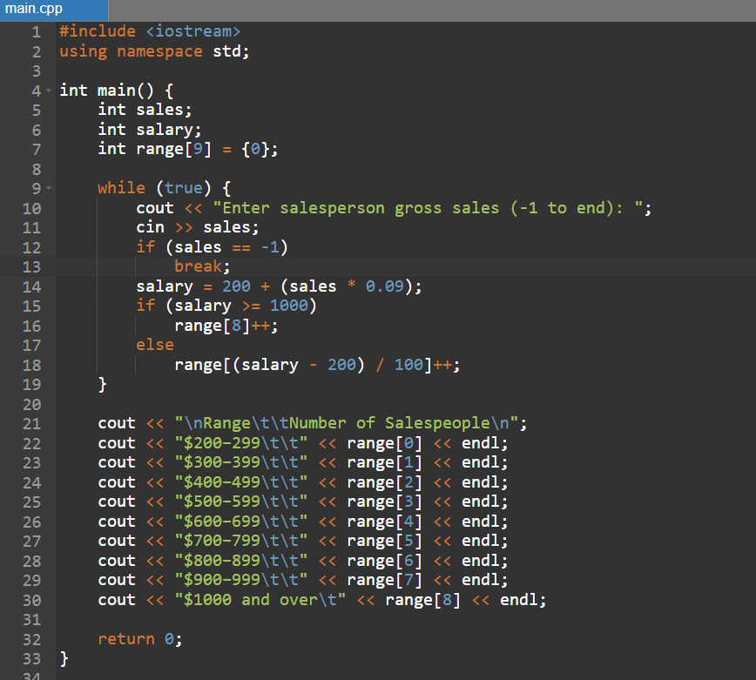

- Write loops that perform each of the following one-dimensional array operations:
a) Read the 20 elements of double array sales from the keyboard.
b) Add 1000 to each of the 75 elements of double array allowance.
c) Initialize the 50 elements of integer array numbers to zero.
d) Print the 10 values of integer array GPA in column format.
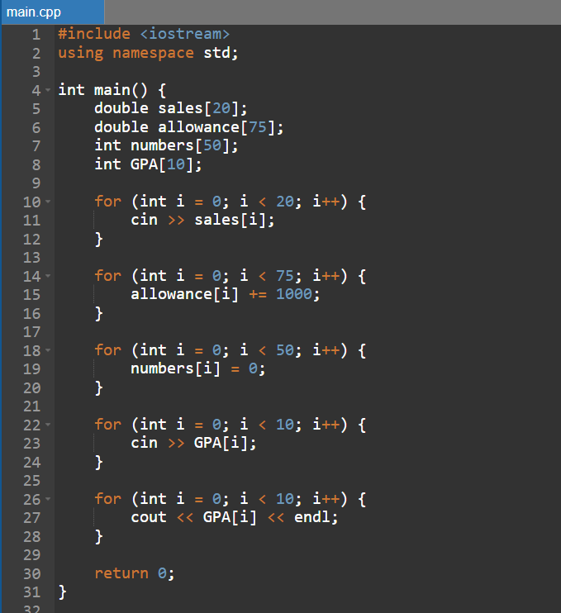
- Use one-dimensional arrays to solve the following problem. Read in two sets of numbers, each having 10 numbers. After reading all values, display the unique elements common to both sets of numbers.
